Student Grievance Redressal Committee
As per the directives of APJ Abdul Kalam Technological University (APJAKTU), engineering colleges affiliated with the university are required to establish a Student Grievance Redressal Committee (SGRC). This committee serves as a structured mechanism to address and resolve student grievances related to academic, administrative, and other matters within the institution.​
Objectives
The primary objectives of the SGRC are to:
- Provide a fair, impartial, and consistent mechanism for redressal of student grievances.
- Promote a harmonious educational environment by addressing issues promptly and effectively.
- Ensure confidentiality and sensitivity in handling grievances.
- Uphold the dignity of the institution by fostering respectful relationships among students, faculty, and staff.​
Composition
The present Student Grievance Redressal Committee is given below:

Sl. No. | Name | Designation | Email
1 | Dr. K Krishnakumar, Principal | Chairperson | principal@sbce.ac.in
2 | Dr. Saji Varghese, Vice Principal | Co-Chairperson | saji57@yahoo.com
3 | Dr. Sujith Kumar, PG Dean | Convener | cs.sujith@sbcemail.in
4 | Mr. Harikrishnan G, AP, ME | Member | harikrishnangs24@gmail.com
5 | Ms. Priya R, AP, BS | Member | priyarochu@gmail.com
6 | Ms. Chinchu Elezebeth, AP, BT&BCE | Member | chinchuelezebeth@gmail.com
7 | Ms. Sreelekshmi S., AP, CE | Member | ce.aswathys@sbcemail.in
8 | Ms. Reshmi S, AP, CSE | Member | cs.reshmis@sbcemail.in
9 | Ms. Anju Viswam, AP, AI&ML | Member | cs.hema@sbcemail.in
10 | Mr. Hari S, AP, ECE | Member | hari.sivankylm@gmail.com
11 | Mr. Ananthu Vijayakumar, AP, EEE | Member | ee.ananthuv@sbcemail.in
12 | Ms. Sholly Joseph, PRO | Member | shollyjoseph12@gmail.com
13 | Special invitee | Student Member | abhinandh890@gmail.com

- Grievance Redressal Mechanism
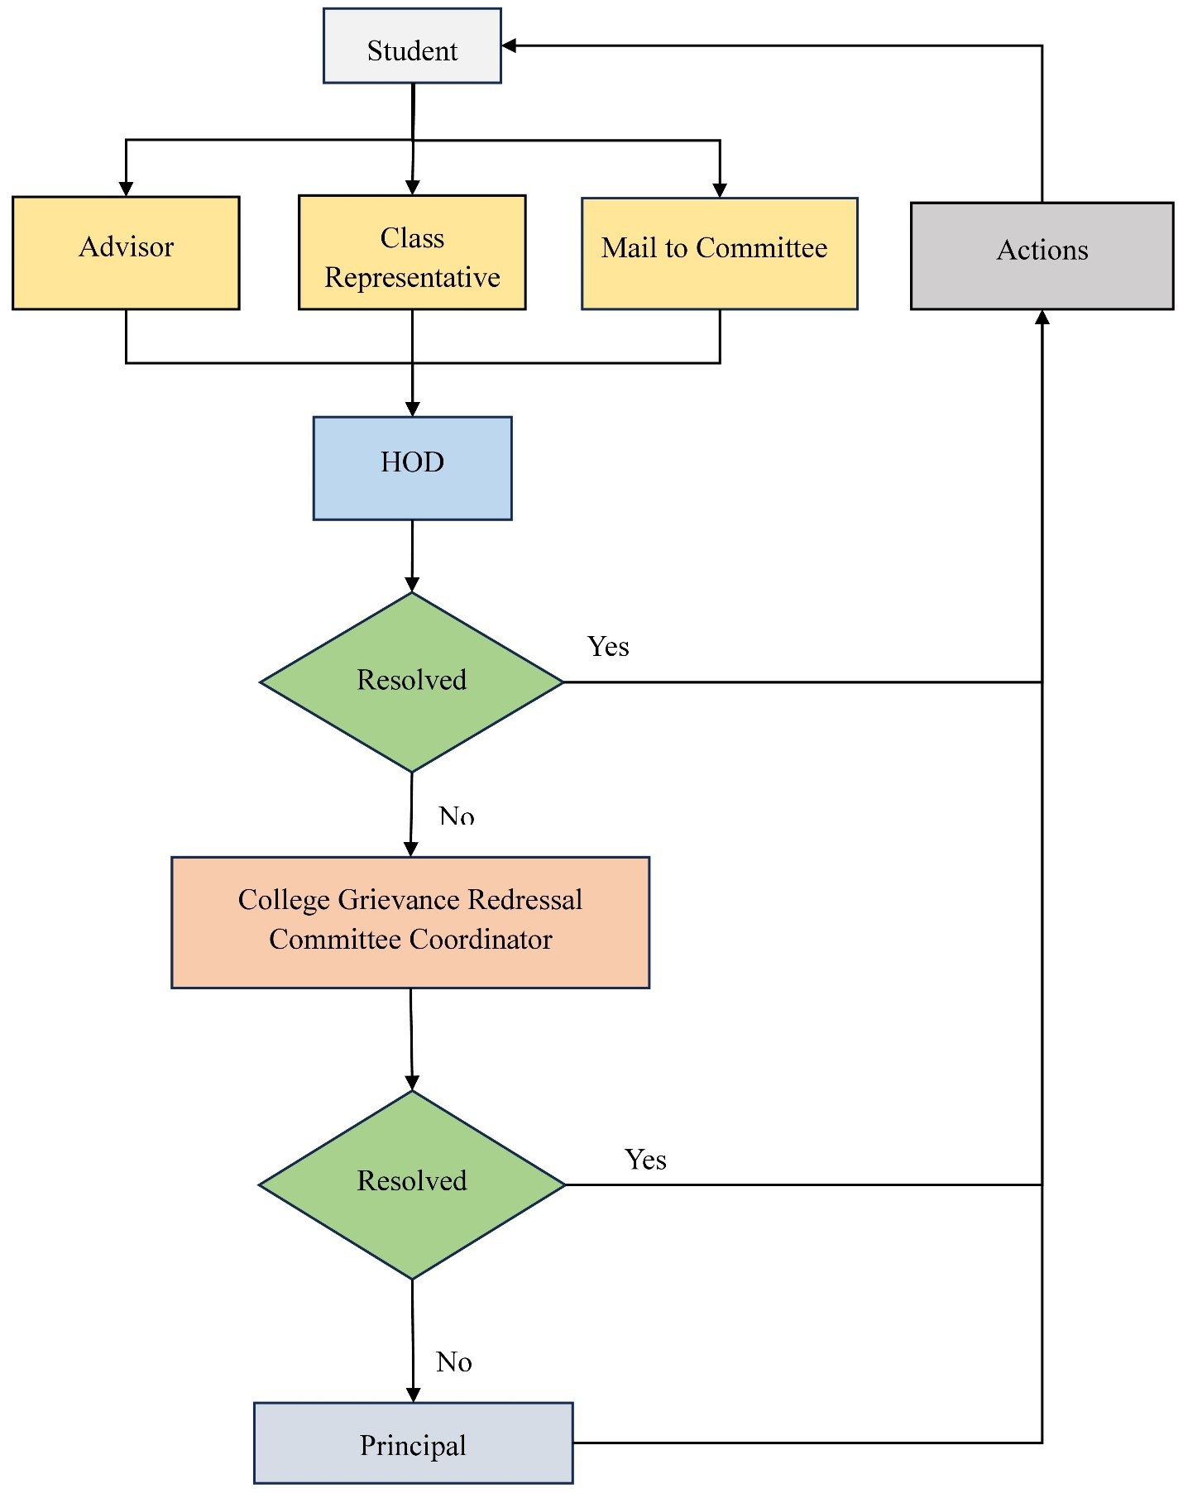
Functions
The SGRC is entrusted with:
- Receiving and documenting grievances from students.
- Conducting thorough investigations into the complaints.
- Facilitating discussions between aggrieved parties to reach amicable solutions.
- Recommending appropriate actions or remedies based on findings.
- Maintaining records of grievances and resolutions for future reference.​

